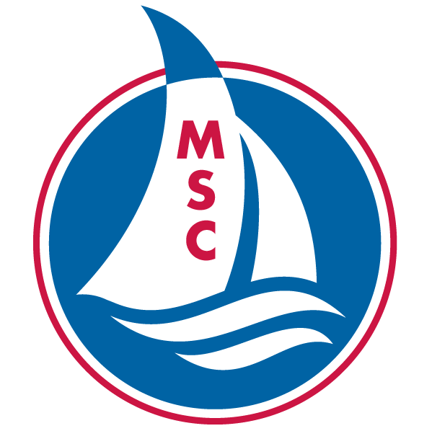
MINNEAPOLIS SAILING CENTER
EMPLOYMENT APPLICATION

Please complete this form and return to: info@sailmpls.org

We are an Equal Opportunity Employer and fully subscribe to the principles of Equal Employment Opportunity. Applicants and/or employees are considered for hire, promotion and job status, without regard to race, color, religion, creed, sex, marital status, national origin, age, physical or mental disability.

CONTACT INFORMATION
Name: Date of Birth:
Address:
City: State: Zip:
Phone: E-mail:

AVAILABILITY
Position(s) you are applying for:

What is your availability during the summer - Start Date: End Date:

How many hours per week are you available for teaching?

What days of the week are you available?

Do you have any summer commitments that require time away from the Sailing Center?

EXPERIENCE
Describe your sailing experience (include kinds of boats sailed):

Why do you want to be an MSC sailing instructor and what do you feel you could bring to the program?

Do you have experience working with children or teaching, describe?

Do you have a class or age group that would be a good fit for you, why?

Do you have experience working with people from diverse racial or cultural backgrounds, describe?

MSC's Equity and Inclusion Initiative has a goal of more proportionally representing the diverse demographics of our community in our staff, membership, and students. MSC's mission is to foster an inclusive, sustainable community and to teach sailing to all. How will you further the E&I Initiative and MSC's mission in this role?

Are there any other school, life, or job experiences, perhaps as a volunteer, that would be relevant to your performance?

EMPLOYMENT AND EDUCATION HISTORY
List the jobs you have held, starting with the most recent:

Dates Name/Address of Employer Position Describe Role and Responsibilities

List the schools and education level achieved, starting with the most recent:
Education Level Name of Schools Years Attended Graduation Date

TRAINING AND CERTIFICATIONS
Indicate any training, certifications, and skills that you have:

US Sailing Certification: Level 1 ☐ Level 2 ☐ Level 3 ☐

First Aid and CPR Certified: Yes ☐ No ☐

Other safety courses or certifications, describe:

Check all skills that apply:
☐ Driven small motorboats
☐ Operated an outboard motor
☐ Boat repair
☐ Driver’s License
☐ Other, describe:

REFERENCES
Personal references whom we may contact:
Name: Phone: Relationship:

Name: Phone: Relationship:

Name: Phone: Relationship:

SIGNATURE
By writing my name below, I certify that all information provided is complete, true, and accurate.

Signature: Date:

